**Blood: Structure and Function**

The cells of a multicellular organism, such as a human, need to obtain nutrients from and expel wastes into their external environment. The circulatory system keeps cells in contact with the external environment.

1. List three nutrients that a cell needs in order to survive.
2. List three wastes that a cell needs to remove in order to survive.
3. Nutrients and wastes are transported by blood. Below is a diagram showing the components of blood. Label the parts.

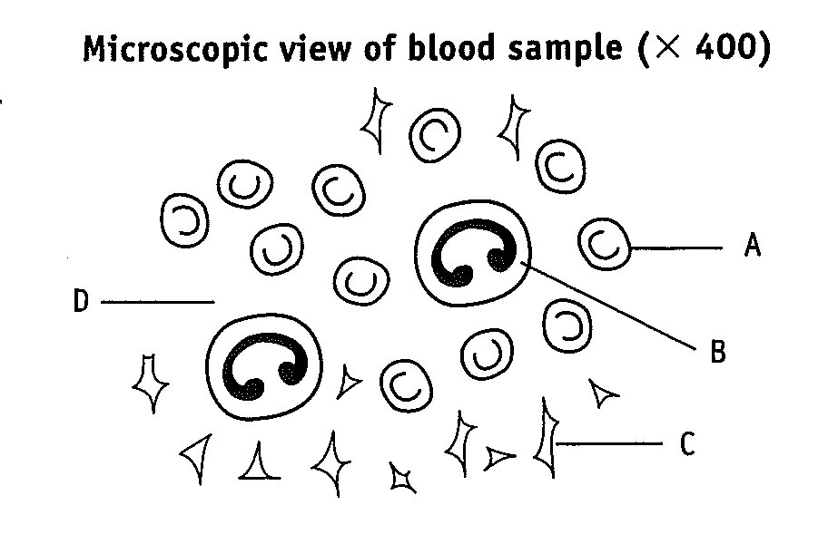

1. What is the function of the parts labelled A, B and C?
2. Describe the composition of the fluid labelled D?

Below is a diagram of a capillary bed.

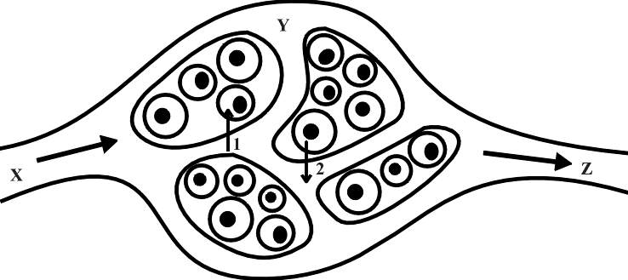

1. Name the parts labelled X, Y and Z.
2. List 4 substances represented by the arrow numbered 1.
3. List 4 substances represented by the arrow numbered 2.
4. Name two cellular processes that require the substances represented by Arrow 1.
5. What would happen to the cell if the substances represented by Arrow 2 were not able to leave the cell? Give two answers.

**The Heart**

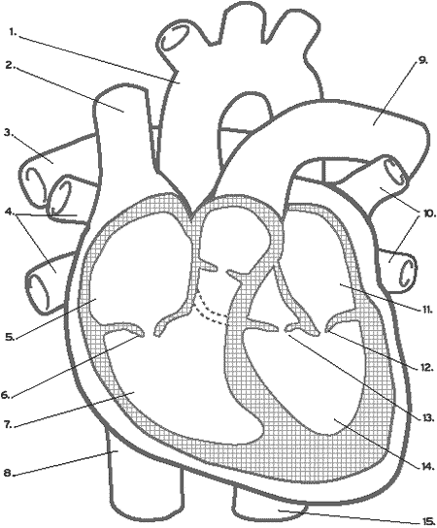

Blood

Log on to the following website and use the information there to answer the questions below. You may have to look elsewhere for the answers to the questions in *italics.*

<http://sln.fi.edu/biosci/blood/blood.html>

**Red Blood cells (Erythrocytes)**

* + - How long do red blood cells live?
    - Why are red blood cells red in colour?
    - What is the purpose of haemoglobin?
    - *Name the vital organelle that is not present in a red blood cell.*
    - Identify the four main blood types
    - On what basis are red blood cells classified into the four groups?
    - What happens when blood types are mixed?
    - If you need blood, which blood type is the most advantageous to have?

# Where are red blood cells formed?

**Plasma**

* + - What is the major component of plasma?
    - List five substances that may be found in plasma, other than water.

**White blood cells (Leucocytes)**

* + - Describe the general function of white blood cells.
    - How long do white blood cells live?
    - Give two reasons why a person’s white blood cell count may be high.

# Where are white blood cells formed?

**Platelets (Thrombocytes)**

* + - Describe (or draw) the appearance of a platelet.
    - Besides platelets, what other substances are necessary for effective clotting?
    - Explain the process that occurs during clotting.

# Name a disorder that is characterised by poor blood clotting?

# Where are platelets formed?

Now log on to the next website and complete the table on white blood cells.

<http://www.unomaha.edu/hpa/blood.html>

|  |  |  |  |  |
| --- | --- | --- | --- | --- |
| **Type of white blood cell** | **Diagram** | **% of total white blood cells** | **Function** | **Examples of diseases**  **(that may affect the numbers of these white blood cells)** |
| Neutrophil |  |  | Phagocytose foreign cells, toxins and viruses. | Raised by acute infection (appendicitis, small-pox or rheumatic fever) Decreased by viral infections (influenza, hepatitis, or rubella) |
| Eosinophil |  | 5% |  |  |
| Basophil |  | 1% |  | Raised by hemolytic anemia or chicken pox |
| Lymphocyte |  |  |  | Decrease in AIDS  Rise in chronic infection or mononucleosis |
| Monocyte |  | 3-9% |  |  |

**Gas exchange: Oxygen and Carbon dioxide Transport**

Humans need to take in oxygen from their environment and expel carbon dioxide back into their environment.

1. Diffusion is the important principle that allows gas exchange to take place. Define the term diffusion.
2. What is a concentration gradient?
3. Use the following information to explain how oxygen is absorbed into the blood.

|  |  |
| --- | --- |
| Partial Pressure of O2 in the lungs | 100 mm of Hg |
| Partial Pressure of O2 in the blood entering the lungs | 40 mm of Hg |

Predict what would happen if the partial pressure of O2 in the lungs was reduced to 65 mm of Hg, while the partial pressure of O2 in the blood entering the lungs remained the same.

1. Name the important chemical found in the blood that allows it to transport oxygen effectively.
2. Outline the three ways in which carbon dioxide transported in the blood?

The following chemical equation shows how oxygen combines with this chemical

Hb4 + 4O2 ↔ Hb4O8

1. What is the significance of the symbol ↔ in the equation?
2. The surface area of the lungs of an average adult is between 50m2 and 70m2. The amount of blood in the capillaries in the lungs is about 60 to 100 mL. Explain the importance of these two sets of figures.
3. What are three important physical features that are needed for a gas exchange surface to be efficient?

The diagram below shows a transverse section (T.S.) through a red blood cell.

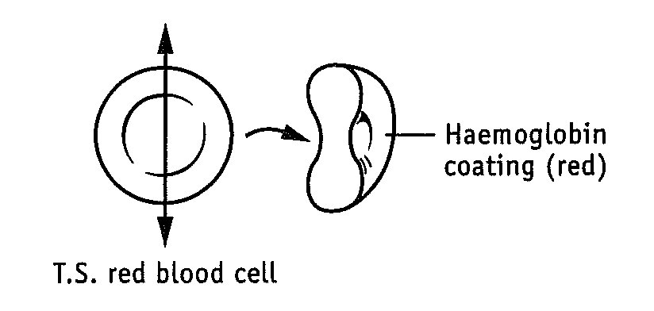

1. Comment on the importance of the shape of red blood cell.
2. Carbon monoxide bonds to haemoglobin about 250 times more readily than oxygen. What effect would relatively low concentrations of carbon monoxide have on the body’s ability to transport oxygen?

**The Circulation of Blood**

1. Study the heart diagram below and compete the following table.

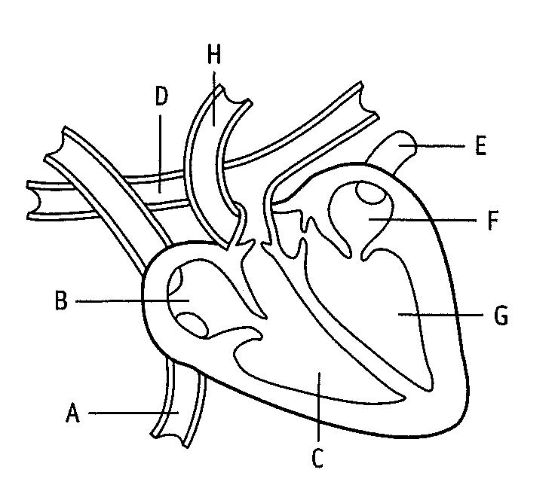

|  |  |  |
| --- | --- | --- |
|  | Structure | Function |
| A |  |  |
| B |  |  |
| C |  |  |
| D |  |  |
| E |  |  |
| F |  |  |
| G |  |  |
| H |  |  |

1. On the heart diagram, trace the pathway followed by :

Oxygenated blood (in red)

Deoxygenate blood (in blue)

1. Why does the left ventricle have a thicker muscular wall than the other heart chambers?
2. What is the main function of the valves in the heart?

The diagrams below represent the three main types of blood vessels.

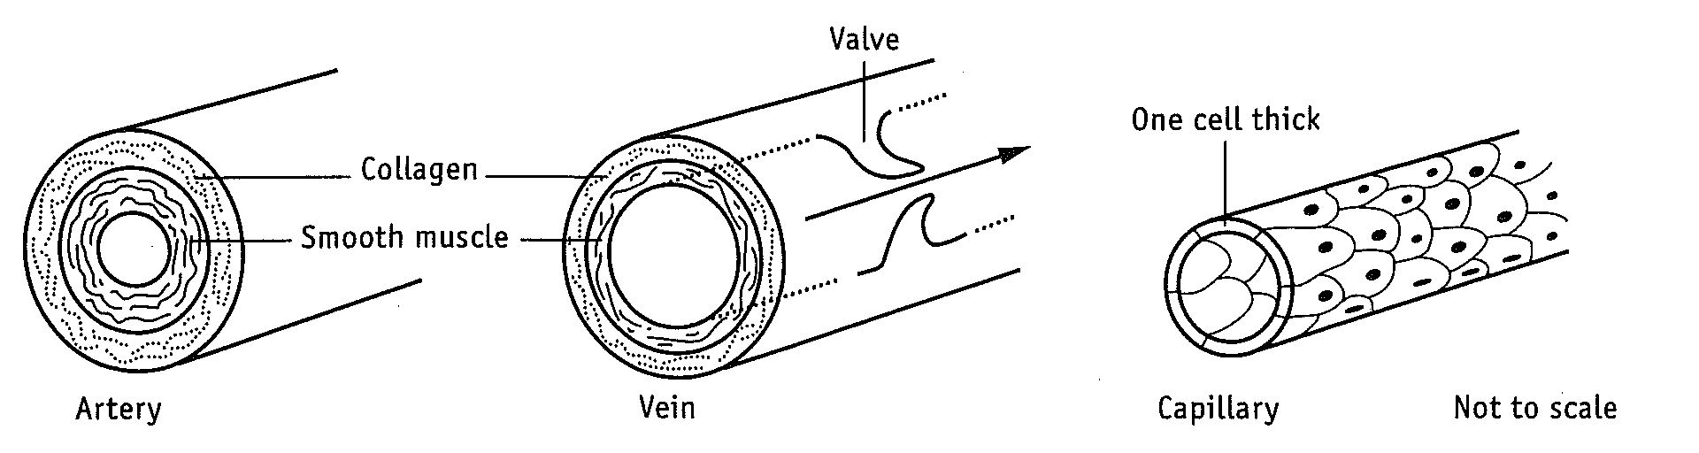

1. Complete the following table comparing the blood vessels.

|  |  |  |  |  |
| --- | --- | --- | --- | --- |
| Blood vessels | Direction of blood flow | Valves | Thickness of walls | Surface Area to volume ratio |
| Artery |  | None |  | Low |
| Vein | Toward heart |  | Medium |  |
| Capillary |  |  |  |  |

1. Compare and contrast the factors that move blood through arteries with those moving blood through veins.
2. Describe two features of the capillary bed that make it ideally suited as a site for exchanging materials
3. Name three substances that diffuse from the capillary blood to the tissue cells.

**Respiration and the alveolus gas exchange surface**

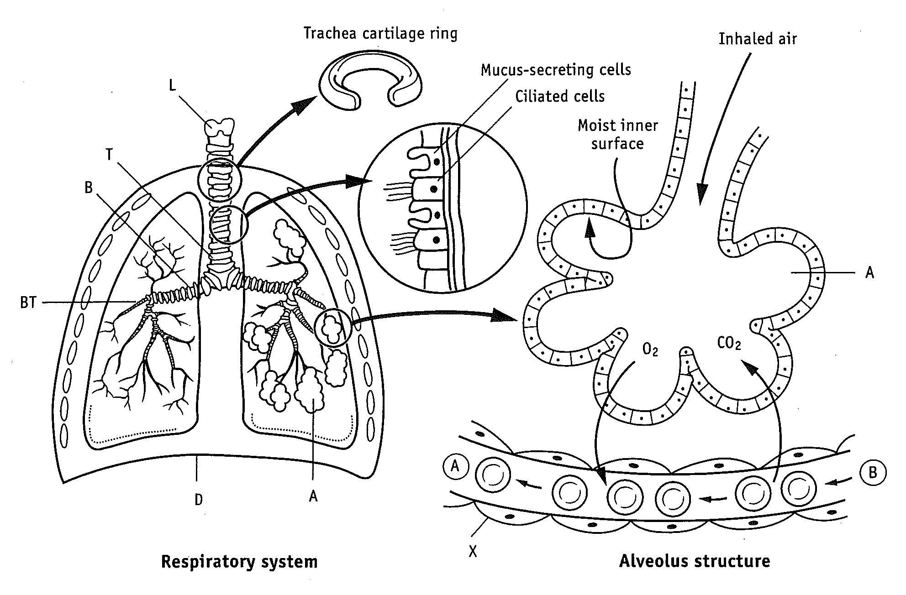

1. Label the parts of the following parts of the respiratory system.

|  |  |  |  |
| --- | --- | --- | --- |
| L |  | A |  |
| T |  | D |  |
| B |  | X |  |
| BT |  |  |  |

1. Describe the main function of the following organs.

|  |  |
| --- | --- |
| Alveolus |  |
| Diaphragm |  |
| Bronchiole tubes |  |
| Larynx |  |

1. Describe a function of the following in the trachea:
   1. The ciliated cells
   2. The mucous produced by the mucous secreting cells
   3. The cartilage rings
2. Write down two differences in the chemical composition of the blood at point A compared to that at point B in the alveolar capillary.
3. What is the function of the respiratory system?
4. A general equation for cellular respiration is

## Oxygen + glucose + ADP → ATP + carbon dioxide + water

All cells in the human body carry out this process. Name the systems that:

1. Supply oxygen to active cells
2. Supply glucose to the cells
3. Remove carbon dioxide from the cells.

**What happens to the air that we breathe in?**

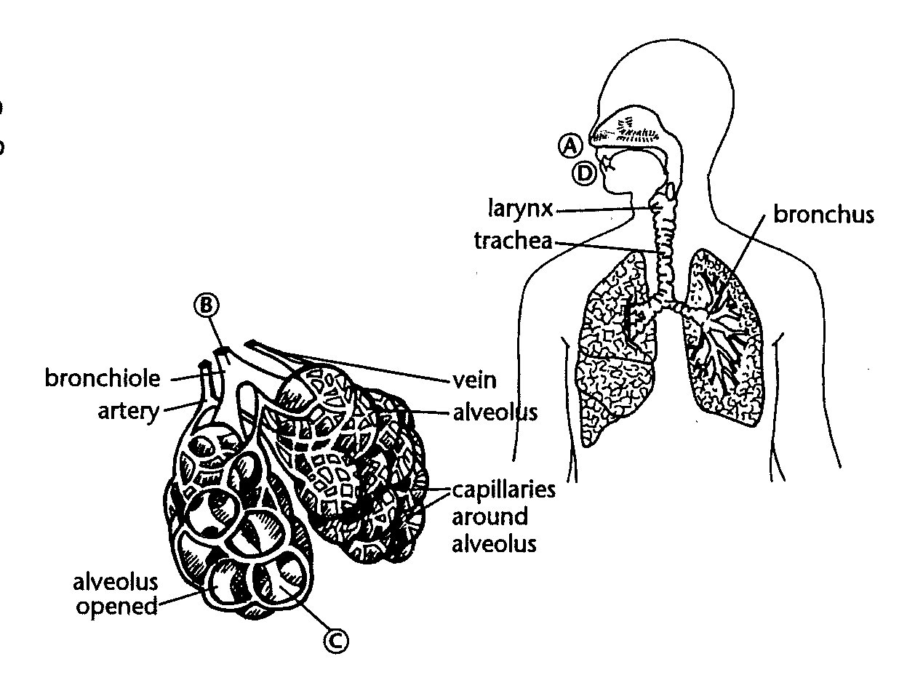The diagram below identifies four key points (A, B, C & D) as air passes in and out of the lungs.

The table below shows the concentration of different gasses at points A, B, C and D.

|  |  |  |  |  |
| --- | --- | --- | --- | --- |
| **Gas in air**  **(percentage)** | **A: Air before entering mouth and nose** | **B: Air in bronchiole before entering alveoli** | **C: Air in alveoli** | **D: Air exhaled from mouth and nose** |
| Nitrogen | 78.62 | 74.09 | 74.90 | 74.50 |
| Oxygen | 20.84 | 19.67 | 13.60 | 15.70 |
| Carbon dioxide | 0.04 | 0.04 | 5.30 | 3.60 |
| Water vapour | 0.50 | 6.20 | 6.20 | 6.20 |

Use the information provided in the diagram and table to answer the following questions.

1. Explain why the percentage of oxygen decreases significantly at Point C.
2. Name the cellular process that uses oxygen in the body.
3. Explain why the percentage of carbon dioxide increases significantly at Point C.
4. Why does the percentage of carbon dioxide decrease slightly between Points C and D?
5. Explain why the percentage of water vapour increases between Points A and B.
6. Why is it necessary for the percentage of water vapour to be relatively high in the alveoli?
7. Why is there almost no change in the percentage of nitrogen as air moves from Points B, C and D?
8. Describe how air is filtered as it moves from Point A down to Point C.

**Role of erythrocytes and plasma in the transport**

**of oxygen and carbon dioxide**

The transport of oxygen and carbon dioxide is one of the major functions of the blood.

Complete the following table to show the proportion of O2 and CO2 transported in the blood in different ways.

|  |  |
| --- | --- |
| **Oxygen** | **Carbon dioxide** |
|  |  |
|  |  |
|  |  |

The presence of ___________________ in erythrocytes increases the oxygen-carrying capacity of the blood by about ________ to ________ times.

Write down the formula for the formation of oxyhaemoglobin —

____________ combines with haemoglobin when the O2 concentration is relatively high.

When the concentration of O2 is low, oxyhaemoglobin breaks down into ______________ and __________________. This allows O2 to ______________ into the tissues.

The colour of blood varies from ________ to ________ red depending upon the quantity of __________________ in the blood.

CO2 forms with haemoglobin to form a compound called _______________________

Write down the formula for the formation of hydrogen and bicarbonate ions from CO2 and water.

**Respiratory System**

